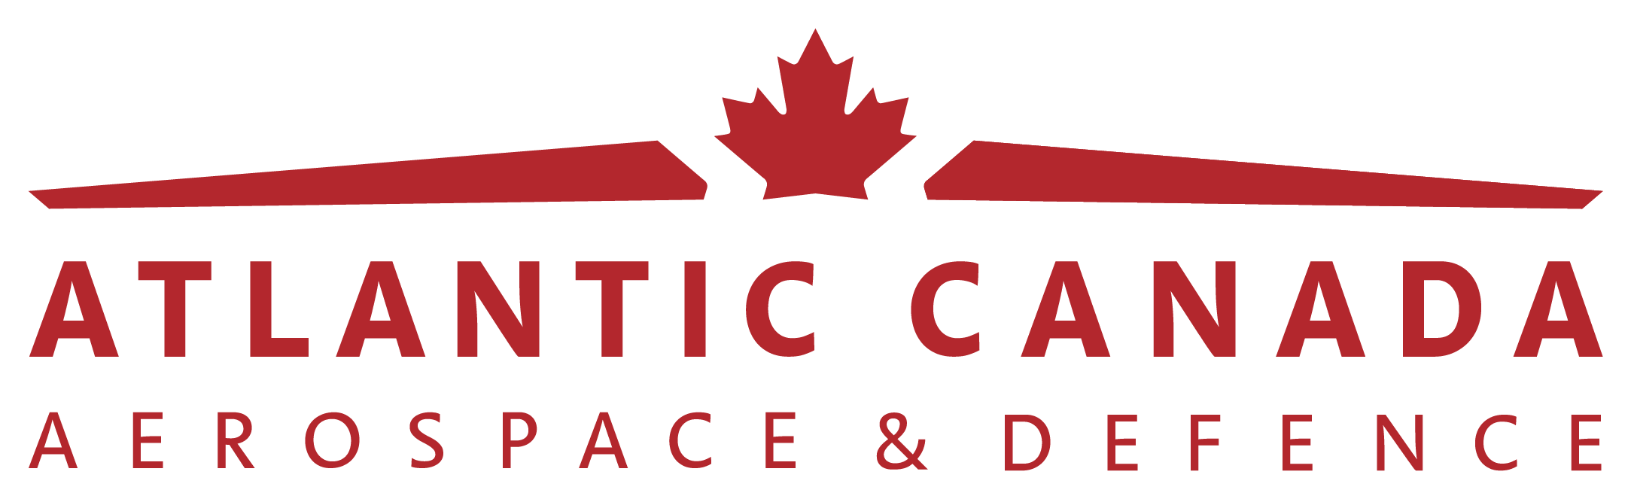

Industry Excellence Awards

The Atlantic Canada Aerospace and Defence Association is pleased to call for nominations for its Industry Excellence Awards. ACADA recognizes the strength and innovation capacity of its members and we want to celebrate the success and excellence of our Atlantic Canadian small-medium enterprises in the aerospace, defence and security industries.

Why Should I Participate?

Award recipients will receive the following benefits:

- Recognition at the DEFSEC event
- Special award logo for use on your website and/or promotional materials
- Recognition via online/social media outlets (ACADA website, twitter, LinkedIn, press release)

Nomination Process

Self or third-party nominations who demonstrate industry excellence in accordance with the award criteria for the category for which they are being nominated will be considered.

Nominations must be submitted by August 23, 2022 to:

Melissa McPhee

Manager, Marketing, Communications, & Events

M: (902) 225-6848

E: melissa@ac-ada.ca

Selection Process

Four awards will be awarded in total (one in each award category). All nominations will be reviewed and evaluated by the awards selection committee which is comprised of stakeholders drawn from the ACADA membership.

General Criteria

Nominees must meet the following mandatory criteria to be considered for award eligibility.

- ACADA member (in good standing)
- Established corporate presence in one or more of the provinces in Atlantic Canada
- Currently supplying products/services in the aerospace, defence or security industries or conducting product/service development or commercialization for future supply in the aerospace, defence or security industries.

Award Categories & Criteria

Category A: Innovation Leader | Recognizes an ACADA member company who has demonstrated significant research and development investment to develop and commercialize a new innovative product or service that has contributed to building the capability of the aerospace, defence or security sector in Atlantic Canada.  In addition to the general and mandatory criteria, nominees must demonstrate fulfillment of one or more of the following award-specific criteria;  - Product/service designed in Atlantic Canada (mandatory)  - Significant investment in research and development resulting in the introduction of a new or enhanced product/service, technology, or process  - Demonstrated creativity and strategic thinking in the development of a new product/service, technology, or process.
Category B:  Business Development Distinction | Recognizes an ACADA member company who has received a significant defence or commercial contract award in the aerospace, defence or security sector as a result of their strategic and dedicated efforts to the business development cycle.  In addition to the general and mandatory criteria, nominees must demonstrate fulfillment of one or more of the following award-specific criteria;  - Successful contract award in the aerospace, defence or security industry valued at $500,000 or more within the April 1, 2021 – March 31, 2022 fiscal year (mandatory)  - Demonstrated commitment/investment to strategic market development and execution of the business development cycle  - Significant annual growth in sales and/or export market diversification  - Recognition of excellence in the vendor supply chain
Category C: Most Promising Start-Up or Business Diversification | Recognizes an ACADA member company who is an early stage start-up or established business who has recently diversified into the aerospace, defence or security industries (less than 2 years) who has demonstrated successful market entry (i.e. established revenues or contracts).  In addition to the general criteria and mandatory criteria nominees must demonstrate fulfillment of one or more of the following award-specific criteria;  - Early stage start-up or established business who has recently diversified into the aerospace, defence or security industries (less than 2 years) who has demonstrated successful market entry through established revenues or contracts (mandatory)  - Timing/Idea: recognition of opportunistic market timing and supply/demand factors contributing to your success  - Team/Business Model: demonstrated leadership and team commitment to the execution of a long-term vision and results driven growth strategy  - Funding: solid and established funding model to enable sustainability and long-term commitment to market execution and growth
Category D:  Diversity and Inclusion Excellence | ACADA recognizes the role of diversity and inclusion as being essential to the growth, structure, and continued success of any organization. This award recognizes an ACADA member company who has shown dedication and commitment to advance equity, inclusivity and diversity of under-represented groups (e.g., women, members of the 2SLGBTQ+ community, Indigenous peoples, persons with disabilities, new Canadians, members of visible minorities, etc.) in the aerospace, defence or security sector in Atlantic Canada.  In addition to the general and mandatory criteria, nominees must demonstrate fulfillment of one or more of the following award-specific criteria:  - Demonstrated measurable improvements in diversity and inclusion within senior management and the general workforce.  - Fostered a culture and environment where diversity is leveraged through efforts such as awareness workshops, leadership development, and the adoption of diversity-enabling policies.  - Recruitment and retention practices which advance the principles of DEI (Diversity, Equity and Inclusion) through the hiring and engagement of underrepresented groups.  - Policies/programs within the organization and/or community that have significant and sustainable impact.

Questions

Questions and application submissions may be directed to:

Melissa McPhee

Manager, Marketing, Communications, & Events

M: (902) 225-6848

E: melissa@ac-ada.ca

Nomination Deadline: August 23, 2022

APPLICATION FORM

Section 1: General Information

Please complete all sections

Nomination Type | Self-Nomination  Third-Party Nomination
Nominated by
(if self, leave blank)
Nominee Information
Company/Organization Name
Contact Name
Email
Phone
Head Office Address
Other locations in Canada or abroad (if applicable)
# of Years in Business
# of Employees
Approximate % of work conducted in the aerospace, defence, security industries
Has the nominee been made aware of this nomination? |  | Yes  No

Section 2: Award Category Selection

Please select an award category and complete the required details (1 category only).

CATEGORY A: INNOVATION LEADER AWARD

Please describe how the company/organization fulfills the criteria for this category and why it should be considered for this award (500 words or less). Insert below or attach a separate document*
If you wish to include additional supporting information (i.e., photos, links, brochures, videos, related awards, etc.), please do so below or attach separate file(s).

CATEGORY B: BUSINESS DEVELOPMENT DISTINCTION
Please describe how the company/organization fulfills the criteria for this category and why it should be considered for this award (500 words or less). Insert below or attach a separate document*
If you wish to include additional supporting information (i.e., photos, links, brochures, videos, related awards, etc.), please do so below or attach separate file(s).

CATEGORY C: MOST PROMISING START-UP or BUSINESS DIVERSIFICATION
Please describe how the company/organization fulfills the criteria for this category and why it should be considered for this award (500 words or less). Insert below or attach a separate document*
If you wish to include additional supporting information (i.e., photos, links, brochures, videos, related awards, etc.), please do so below or attach separate file(s).

CATEGORY D: DIVERSITY AND INCLUSION EXCELLENCE
Please describe how the company/organization fulfills the criteria for this category and why it should be considered for this award (500 words or less). Insert below or attach a separate document*
If you wish to include additional supporting information (i.e., photos, links, brochures, videos, related awards, etc.), please do so below or attach separate file(s).

